**EX NO: 2 CONTROL STATEMENTS**

**DATE: 16-08-23**

**AIM:**

To explore the concepts of Control Structures in Java.

**ALGORITHM:**

**STEP 1: Determine the grades**

1.System.out.println(String) - Print a string to the standard output.

2.LocalDate.now() - To get the current date.

3.LocalTime.now() - To get the current time.

4.Scanner in = new Scanner(System.in) - To create a Scanner object to read user input from the standard input.

5.in.nextInt() - To read and return the next integer from the input.

6.int[] arr = new int[n] - To initialize an integer array to store marks for each subject.

**STEP 2: Random number generator**

1.Random rand = new Random() - To create a random number generator.

2.rand.nextInt(int) - To generate a random integer within the specified range.

3.in.next().charAt(int) - To read the next token as a string and get the character at the specified index.

**STEP 3: No. of. days in the given month**

1.isLeapYear(int) – To check if the given year is leap year or not.

2.noOfDays(int) – To get the no of days in a month.

**STEP 4: Verbalizing the Numbers**

1.VerbalizeNumbers(int) – To convert a number to its verbal representation, and it uses recursion to handle hundreds and thousands.

2.It handles the unit, hundreds and thousands in the separate control statements.

**STEP 5: 24- hour format digital watch**

1.isValidDay(String day) - To check if the given day is valid.

2.getNextDay(String day) - To get the next day based on the input day.

**1. Write a program to determine the custom grade of the marks given.If the marks go beyond 100 or lower than 0 then state the input is invalid.**

**Program**

import java.util.Scanner;

public class Grade3704 {

public static void main(String[] args) {

System.out.println("Bhumisvara");

System.out.println("2021503704");

Scanner scanner = new Scanner(System.in);

System.out.print("Enter the marks: ");

float marks = scanner.nextFloat();

String grade = Grade(marks);

System.out.println("The grade for " + marks + " marks is: " + grade);

}

public static String Grade(float marks) {

if (marks < 0 || marks > 100) {

return "Invalid input";

} else if (marks >= 90) {

return "Grade O";

} else if (marks >= 80) {

return "Grade A+";

} else if (marks >= 70) {

return "Grade A";

} else if (marks >= 60) {

return "Grade B+";

} else if (marks >= 50) {

return "Grade B";

} else {

return "Grade U";

}

}

}

**OUTPUT**

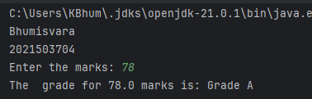

1. **Write a program that simulates the coin tossas head or tail. Use Random number 0 0r 1 to determine the system input. The program should print the result as head if it one and tail if it is zero. Read the input from the user as a character ‘h’ or ‘t’ or ‘H’ or ‘T’ and tell the user whether he or she has predicted the coin toss correctly . Declare the result as Won the toss! Or lose!**

**Program.**

import java.util.Random;

import java.util.Scanner;

public class HeadTail3704 {

public static void main(String[] args) {

System.out.println("Bhumisvara");

System.out.println("2021503704");

Random random = new Random();

Scanner scanner = new Scanner(System.in);

int systemResult = random.nextInt(2);

System.out.print("Predict the coin toss (h/H for head, t/T for tail): ");

char userPrediction = scanner.next().charAt(0);

userPrediction = Character.toLowerCase(userPrediction);

String systemResultString = (systemResult == 1) ? "head" : "tail";

if ((userPrediction == 'h' && systemResult == 1) || (userPrediction == 't' && systemResult == 0)) {

System.out.println("You won the toss!");

} else {

System.out.println("You lose!");

}

System.out.println("Coin toss result: " + systemResultString);

scanner.close();

}

}

**OUTPUT**

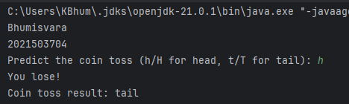

**3.Write a program to output the number of days of the month(1 to 12) in the given year.The value of the month February is 28 or 20 based on the leap year. Give warning for invalid input that is of digit less than 4 or greater than 5. Hint: Use Switch statement.**

**Program**

import java.util.Scanner;

public class leapyear3704 {

public static void main(String[] args) {

System.out.println("Bhumisvara");

System.out.println("2021503704");

Scanner scanner = new Scanner(System.in);

System.out.print("Enter the year: ");

int year = scanner.nextInt();

if (year < 1000 || year > 9999) {

System.out.println("Invalid year input. Year should be between 1000 and 9999.");

return;

}

System.out.print("Enter the month (1 to 12): ");

int month = scanner.nextInt();

if (month < 1 || month > 12) {

System.out.println("Invalid month input. Month should be between 1 and 12.");

return;

}

int daysInMonth;

switch (month) {

case 2:

if ((year % 4 == 0 && year % 100 != 0) || (year % 400 == 0)) {

daysInMonth = 29;

} else {

daysInMonth = 28;

}

break;

case 4: case 6: case 9: case 11:

daysInMonth = 30;

break;

default:

daysInMonth = 31;

break;

}

System.out.println("Number of days in the specified month: " + daysInMonth);

scanner.close();

}

}

**OUTPUT**

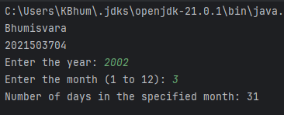

1. **Write a program that verbalize the user inputs between 1 and 9999 number. For example Input number :852 Eight hundred and fifty-two**

Program.

import java.util.Scanner;

public class input3704 {

private static final String[] units = {"", "One", "Two", "Three", "Four", "Five", "Six", "Seven", "Eight", "Nine"};

private static final String[] teens = {"", "Eleven", "Twelve", "Thirteen", "Fourteen", "Fifteen", "Sixteen", "Seventeen", "Eighteen", "Nineteen"};

private static final String[] tens = {"", "Ten", "Twenty", "Thirty", "Forty", "Fifty", "Sixty", "Seventy", "Eighty", "Ninety"};

public static void main(String[] args) {

System.out.println("Bhumisvara");

System.out.println("2021503704");

Scanner scanner = new Scanner(System.in);

System.out.print("Input number (1 to 9999): ");

int number = scanner.nextInt();

if (number < 1 || number > 9999) {

System.out.println("Invalid input. Number should be between 1 and 9999.");

return;

}

String verbalizedNumber = convertToWords(number);

System.out.println("Verbalized number: " + verbalizedNumber);

scanner.close();

}

public static String convertToWords(int num) {

if (num == 0) {

return "Zero";

}

if (num < 10) {

return units[num];

}

if (num < 20) {

return teens[num - 10];

}

if (num < 100) {

return tens[num / 10] + ((num % 10 != 0) ? " " + units[num % 10] : "");

}

if (num < 1000) {

return units[num / 100] + " Hundred" + ((num % 100 != 0) ? " and " + convertToWords(num % 100) : "");

}

return units[num / 1000] + " Thousand" + ((num % 1000 != 0) ? " " + convertToWords(num % 1000) : "");

}

}

**OUTPUT**

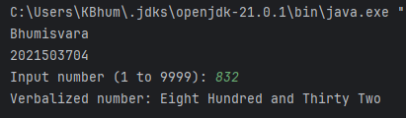

**5.Write a program to create 24-hour digital watch. Get the input from the user for the day(Mon, Tue, Wed, Thu, Fri, Sat, Sun) , hour (24-hour) , minute and seconds . Theinput of the user is valid then the digital clock should advance the input by one second and display the new day, hour, minute and second.**

**Program.**

import java.util.Scanner;

public class time3704 {

public static void main(String[] args) {

System.out.println("Bhumisvara");

System.out.println("2021503704");

Scanner scanner = new Scanner(System.in);

System.out.print("Input day (Mon, Tue, Wed, Thu, Fri, Sat, Sun): ");

String day = scanner.nextLine();

System.out.print("Input hour (0-23): ");

int hour = scanner.nextInt();

System.out.print("Input minute (0-59): ");

int minute = scanner.nextInt();

System.out.print("Input second (0-59): ");

int second = scanner.nextInt();

if ((hour < 0 || hour > 23) || (minute < 0 || minute > 59) || (second < 0 || second > 59)) {

System.out.println("Invalid input");

} else {

second++;

if (second == 60) {

second = 0;

minute++;

if (minute == 60) {

minute = 0;

hour++;

if (hour == 24) {

hour = 0;

day = getNextDay(day);

}

}

}

System.out.println("New time: " + day + " " + hour + " " + minute + " " + second);

}

scanner.close();

}

private static String getNextDay(String currentDay) {

String[] days = {"Mon", "Tue", "Wed", "Thu", "Fri", "Sat", "Sun"};

for (int i = 0; i < days.length; i++) {

if (currentDay.equalsIgnoreCase(days[i])) {

if (i == days.length - 1) {

return days[0];

} else {

return days[i + 1];

}

}

}

return currentDay;

}

}

**OUTPUT**

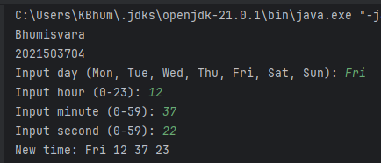

**RESULT:**

Control statements in Java has been implemented successfully.